2016-2017 Education Year Kirkille Primary School 1st English Exam of 1st Midterm for Grade 7
Name&Surname:
- Aşağıda verilen sıfatları uygun resimlerle eşleştiriniz. ( 24 p. )
Stubborn – Beautiful – Fat – Tall – Stingy – Punctual – Ugly - Lazy
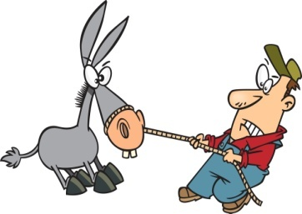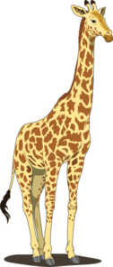
……………………………….. …………………………………. …………………………. ………………………………
............................... …………………………… ………………………. …………………………
- Aşağıdaki sıfatları uygun gruba yerleştiriniz. ( 16 p. )
Honest – selfish – medium height – tall – well built – slim – selfish – thoughtful
PERSONALİTY PHYSICAL APPEARANCE

- Aşağıdaki boşlukları “ was – were “ ile doldurunuz.( 15 p. )

- We ………………. At school last Saturday.
- She ………………… in South Africa last month.
- He …………………… happy.
- You …………………… very busy on Friday.
- I …………………….. very busy.
- Aşağıdaki sıfatların “ comparative “ hallerini boşluklara yazınız.( 15 p. )
- She is ……………………………………..( beautiful ) than her sister.
- My doll is …………………………………….( lovely ) yours.
- He is ………………………..( bad ) student than his brother.
- The weather is ………………………………( good ) than yesterday.
- Antalya is …………………………….( hot ) than Erzurum.

- Aşağıdaki soruları cevaplarıyla eşleştiriniz. ( 16 p. )
- Where did you study fort he exam?...........
- Did Sue enjoy her holiday?............
- What did you do last night?..........
- When did he move to the USA?.........
- Why did you stay at home?..........
- What time did you finish your homework?.........
- Did your parents like the film?...........
- Who painted this Picture?.............

- In 2010.
- My sister.
- At 10 o’clock.
- No, they didn’t.
- Yes, she did.
- In the library.
- I watched TV.
- Because I was ill.

- Aşağıdaki fiilerin “ past form ” larını ( 2. Hallerini ) yazınız. ( 14 p. )
- Go………………………………………….
- Take ……………………………………..
- Come …………………………………..
- Do …………………………………..
- Eat …………………………………..
- Swim …………………………………
- Drink ……………………………………
GOOD LUCK !!!

