Name / Surname: Number:

2015-2016 ACADEMIC YEAR E.T.S.O. SECONDARY SCHOOL 1ST TERM 1ST WRITTEN EXAM FOR GRADE 7

A) Put the adjectives into the correct category. (15x2=30 points)
beautiful – clumsy – easy-going – forgetful – generous – honest – outgoing – overweight – selfish – stubborn– well-built – punctual – slim – thoughtful – short
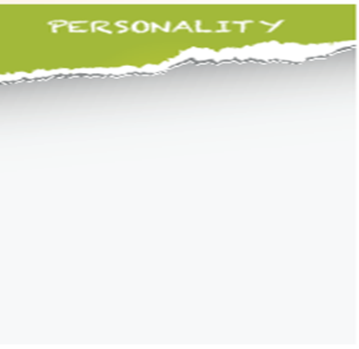
B) Match the pictures with the sentences. (4x2=8 points)
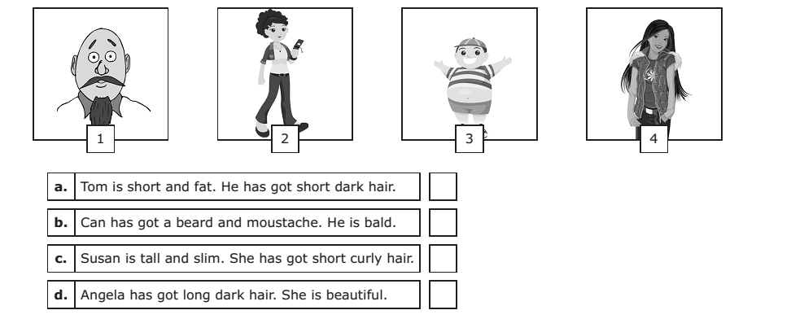
C) Complete the sentences with the comparative form of the adjectives. (6x2=12 points)
1- Planes are …………………………………………………………… than trains. (fast)
2- My brother is ……………………………………………………………. than me. (hard-working)
3- I want to have a ………………………………………………………… bike. (big)
4- Learning English is ……………………………………………………………….. than learning Chinese. (easy)
5- I think birds are …………………………………………………………….. pets than dogs. (good)
6- Konya is ……………………………………………………. than Edirne. (large)
D) Complete the paragraph with ‘was’ or ‘were’. (5x2=10 points)
1- My parents ……………………… at home last night.
2- Jane’ s grandfather ………………………. a teacher.
3- Enstein ……………………… famous for his theory of relativity.
4- I met my best friend when we ………………………… at kindergarten.
5- I ………………… at the library at 5 o’clock yesterday.

E) Complete the text with the Past Simple. (15x2=30 points)
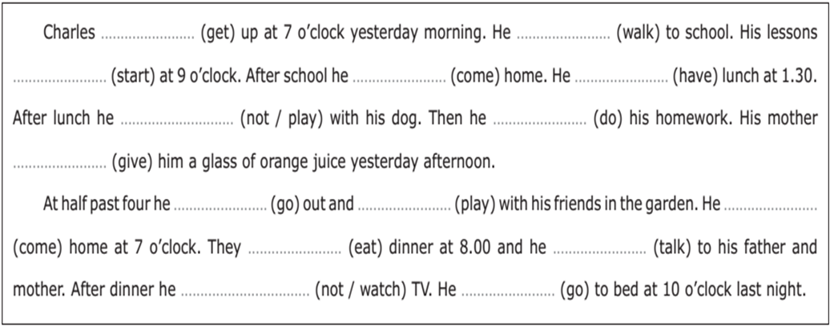

F) Circle the correct choice. (5x2=10 points)
1- A: Where did you go last night?
B: ………………… .
a) To the cinema. b) At 3 o’clock.
c) John and Mike. d) Go swimming.

2- A: When did you meet your friends?
B: ………………….. .
a) On Mondays. b) Every day.
c) Yesterday. c) Next week.

Teacher: Neslihan KURBAN
3- A: Did Mary do her homework?
B: ………………………….. .
a) Yes, she was. b) Yes, she did.
c) Yes, we did. d) She did her homework.

4- Did you ………………… dinner with your family?
a) has b) had
c) haved d) have

5- My father was very handsome …………………… .
a) when she was young b) always
c) when he was young d) never

