NAME SURNAME: NO: GRADE: 5/A
- WRITE THE CORRECT NUMBER GIVEN BELOW (6x2: 12 PTS)

1- one 4- …………………. 7- seven 10- ………………….
2- …………………. 5- five 8- …………………. 11- eleven
3- three 6- …………………. 9- nine 12-………………….
B) WRITE THE CORRECT TIME UNDER THE WATCHES GIVEN BELOW (5x3: 15 PTS)
-half past ten -quarter past six -three o’clock -quarter to one -quarter to five
WHAT TIME IS IT?
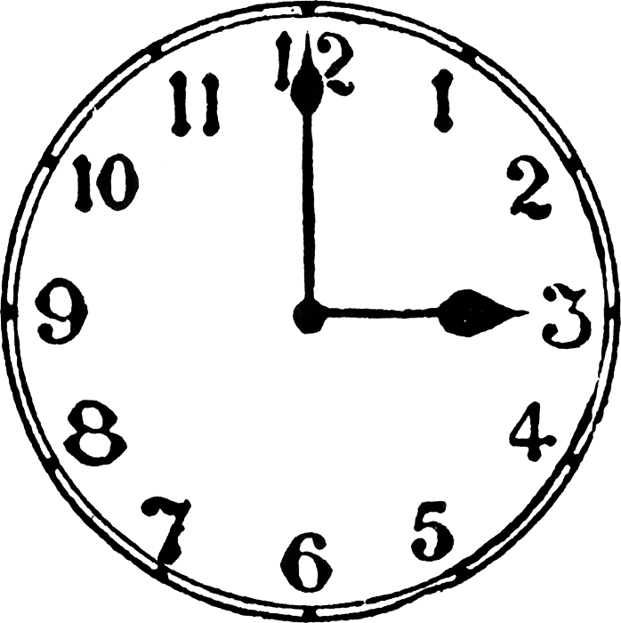 | 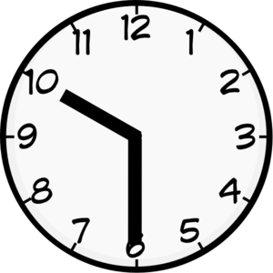 | 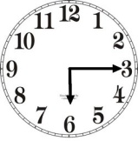 | 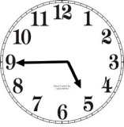 | 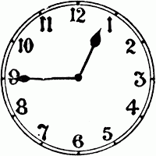
It’s … | It’s … | It’s … | It’s … | It’s …

- WRITE THE DAYS INTO THE TABLE (4x3: 12 PTS)
Wednesday | Thursday | Tuesday | Friday | Saturday | Monday | Sunday

PAZARTESİ | : Monday | CUMA | : Friday
SALI | : …………………… | CUMARTESİ | : ……………………
ÇARŞAMBA | : Wednesday | PAZAR | : ……………………
PERŞEMBE | : ……………………

- WRITE THE NAMES OF THE SEASONS UNDER THE CORRECT PICTURE (4x3: 12 PTS)
-fall | -spring | -summer | -winter

 |  |  | 
- WRITE THE CORRECT SUBJECT PRONOUNS INTO THE TABLE (4x3: 12 PTS)
They | You | You | It | He | She | We | I

Ben | : I | O (Erkek) | : He | Biz | : We
Sen | : …………….. | O (Kız) | : …………….. | Siz | : ……………..
 |  | O (Hayvan) | : …………….. | Onlar | : They
- WRITE THE CORRECT QUESTION WORDS INTO THE TABLE (3x2: 6 PTS)
Who | How | When | Where | Why | What

Ne | : What | Ne Zaman | : When | Kim | : Who
Nerede | : …………….. | Nasıl | : …………….. | Neden | : ……………..

- WRITE THE CORRECT FAMILY MEMBER INTO THE TABLE (3X2: 6 PTS)
Father | Mother | Sister | Brother | Grandfather | Grandmother
Nine
……………………………..
Dede
Grandfather

Anne
……………………………..

Baba
Father

Ben
ME

Erkek Kardeş
……………………………..

Kız Kardeş
Sister

H )WRITE THE PHRASES UNDER THE CORRECT PICTURES (5x3: 15 PTS)
- watch TV - wash hands and face -classes start - get up - have breakfast

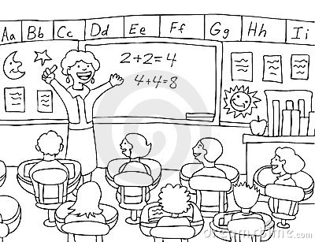 | 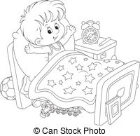 | 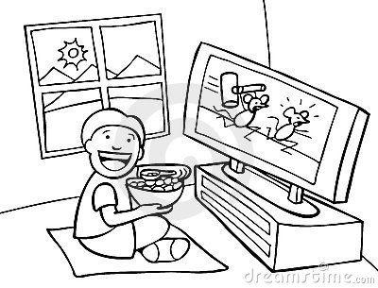 | 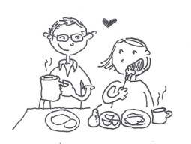 | 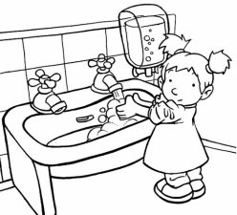
……………………. | ……………………. | ……………………. | ……………………. | …………………….

I) WRITE THE PLACES UNDER THE CORRECT PICTURES (5x2: 10 PTS)
- Police Station - Playground - Stationery - Toy Shop - School

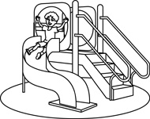 | 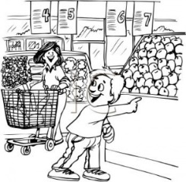 |  | 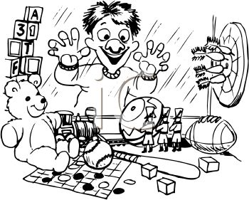 | 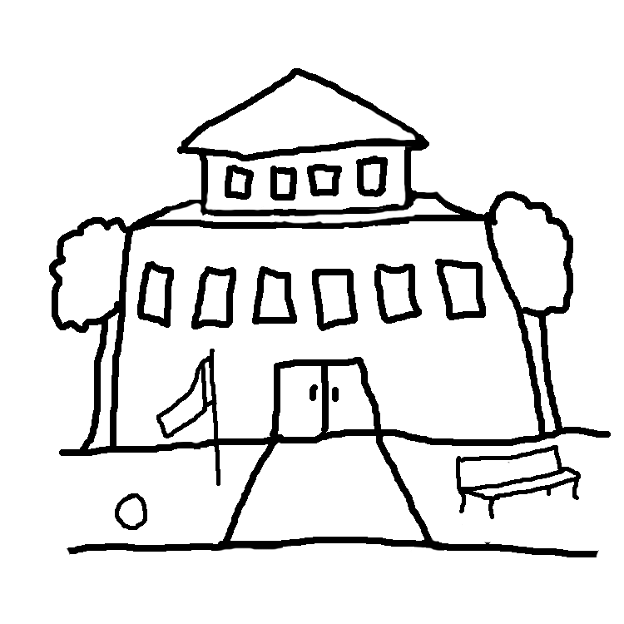
……………………. | ……………………. | ……………………. | ……………………. | …………………….
Baki ÖZEN
İngilizce Öğretmeni

