ADI/SOYADI: SINIFI/ÖĞR. NO:
2015-2016 ACADEMIC YEAR E.T.S.O. SECONDARY SCHOOL 5TH GRADE 1ST TERM 1ST WRITTEN EXAM
A. Aşağıdaki kelimeleri uygun resmin altına yazınız.(10*2=20)
play computer games / brush teeth/ go to school / do homework / get dressed /
watch TV / wash your face / have breakfast / go to bed / get up
 |  |  |  | 5

B. Aşağıda yazılı zamanları saatlerin içine çiziniz.(5*2=10)
It is half past seven. | It is ten o’clock. | It is quarter past one. | It is ten past four. | It is quarter to two.

C. Aşağıdaki cümlelerde koyu renk kelimelerden doğru olanı yuvarlak içine alınız.(10*2=20)
1.I get up /gets up early every morning.
2.Meltem watch / watches TV every evening.
3.They don’t / doesn’t do their homework.
4.Nil and Aynur play / plays tennis on Sundays.
5.Do / Does your mother brush her teeth?
6. He have / has breakfast at 08.00.
7. My cat drink / drinks milk everyday.
8.We don’t / doesn’t have lunch at 12.30
9.Do / Does Ercan play computer game?
10.She sleep / sleeps early every evening.

D. Haritaya bakın. Uygun kelimeyi kullanarak cümleleri tamamlayın. (5*3=15)
*opposite * between
* behind * next to
*in front of
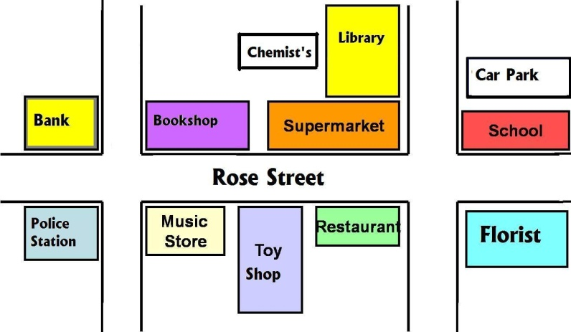

1. The bookshop is ……………………………… the supermarket. 2. The toy shop is ………………………… the restaurant and the music store. 3. The chemist is ………………………….. the library.
4. The police station is …………………………… the bank.
5. The supermarket is ………………………………. the library.
E. Eşleştirin. (5*3=15)
1-  2-  3-  4-  5- 
……………..a) Cross the street. …………….b) Walk over the bridge. ……………..c) Turn right.
……………..d) Go straight ahead. ……………..e) Turn left.
F. Konuşmaları sıralayarak anlamlı bir diyalog oluşturun. (6*2=12)
1. 2. 3.
4. 5. 6.
a) You’re welcome.
b) Excuse me. Is there a police station near here?
c) Thank you very much.
d) Yes, there is one.
e) It’s in Rose Street. Go straight ahead. Turn left. It’s opposite the bank.
f) Where is it?
G. Resimlerde gördüğünüz yer isimlerini yazın. (4*2=8)
1- 2-  3-  4- 
   

