2015-2016 EDUCATION YEAR MEHMET ÇAVUŞ SECONDARY SCHOOL 1ST TERM 1ST ENGLISH EXAM FOR 5TH GRADE
NAME & SURNAME: CLASS: NUMBER: MARK:
A)Write the phrases under the correct picture.(Kelimeleri doğru resmin altına yazınız.)(5x2=10)
get up - get ready for school - catch the school bus - brush teeth - have lunch

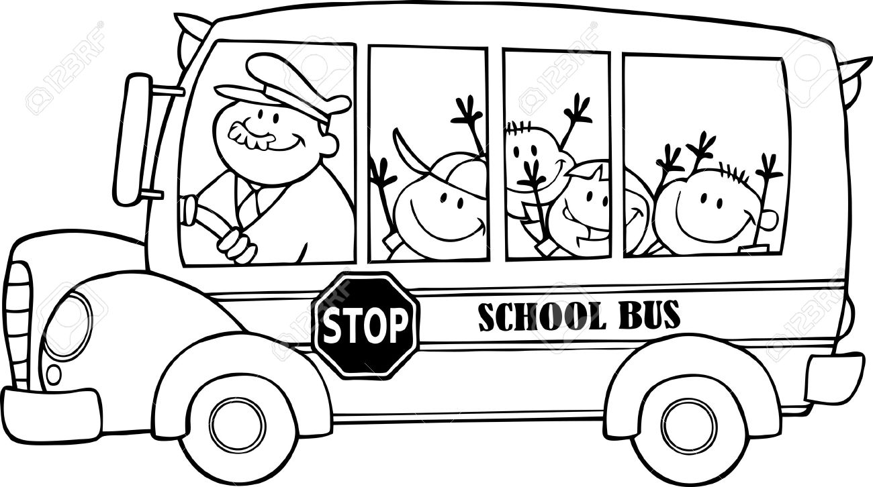 | 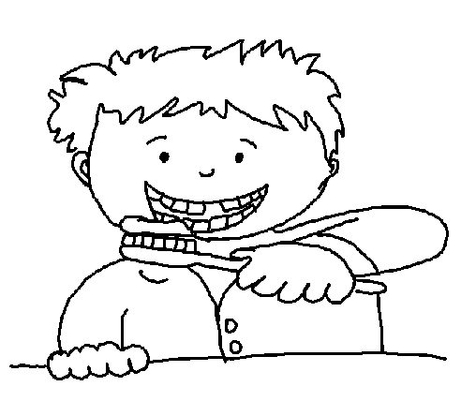 | 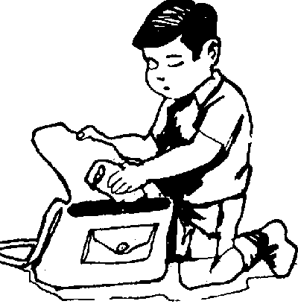 | 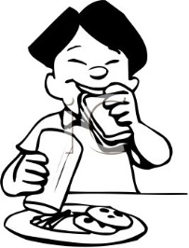 | 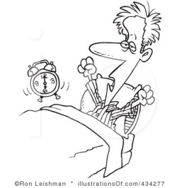

B)Write the phrases under the correct picture.(Kelimeleri doğru resmin altına yazınız.)(5x2=10)
watch TV - wash hands and face -classes start - do homework - have breakfast

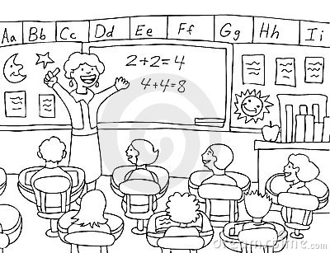 | 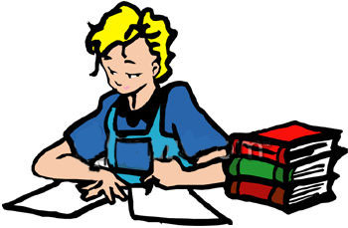 | 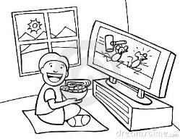 | 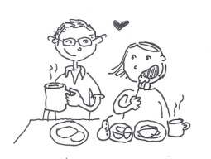 | 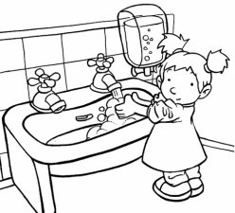

C)Match the pictures with the correct places. (Resimlerle yer isimlerini eşleştiriniz.)(6x2=12)

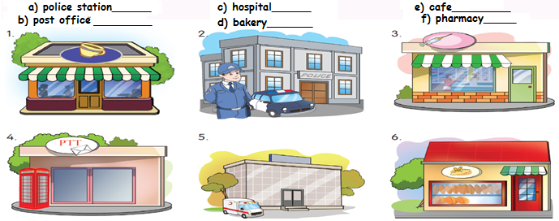

D) Write the days in the correct order. (günleri doğru sırasına göre sıralayınız.)(6x2=12)
Tuesday - Friday - Monday - Sunday - Thursday - Saturday - Wednesday
www.egitimhane.com
1-Monday 2- ___ 3- 4- 5- 6- __ 7- _______

E) Match the directions with the correct picture. (Yönergeleri doğru resimlerle eşleştiriniz)(4x3=12)
1)Turn right - 2) Cross the Street - 3)Turn left - 4)Go straight ahead

a)____ b)____ c)____ d)____
F)Match the time. (Saatleri eşleştiriniz) (4x2=8)
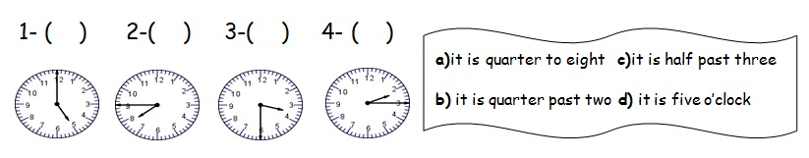

G) Günlük rutin ifadelerini okuyup doğru olan saati yuvarlak içine alınız.(3x3=9)
06:00
07:00
- I get up at seven o’clock.
- I have lunch at the school canteen at twelve o’clock.
11:10
12:00
- I go to bed at half past nine.
09:30
09:20

H)Write the prepositions. ( kelimeleri kutudan seçerek yazın.) (5x3=15)
1.The bus stop is ……………………………… the school.
2.The toy shop is ……………………… the restaurant and the cinema.
3. The pharmacy is ………………………….. the library.
4. The police station is …………………………… the bank.
5. The supermarket is ……………………………. the library.
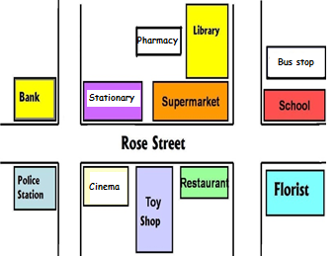
*Opposite * between
* behind * next to *in front of

I) Choose the correct Picture. (Doğru seçeneği işaretleyiniz.)(4x3=12)
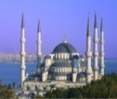

- Meryem : Where is Elif?
Fatma : She is at the ……………………
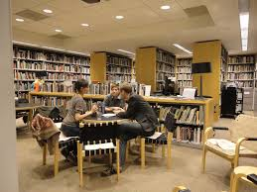
a. library
b. police station
c. pharmacy
d. hospital

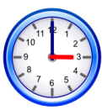
2.What time is it?
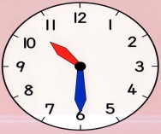
a. It is eleven o’clock.
b. It is quarter past eleven.
c. It is half past ten.
d. It is quarter past two.

3.What is this?
a) hospital b) mosque
c) library d) bakery

4. ___________ is it?
It is three o’clock. (Boşluğa gelecek soruyu işaretleyiniz.)

a) What time b) Who
c) How d) Where

