NAME SURNAME: NO: GRADE: 6/A

- Match the phrases to the pictures (6x4: 24 pts)

play soccer | go online | watch TV | do karate | have a rest | take guitar courses

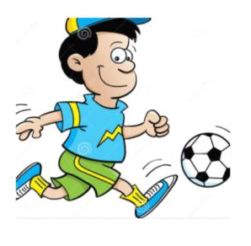

B) Match the phrases to the pictures (6x4: 24 pts)

Bread | Butter | Croissants | Sausages | Olive | Egg

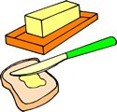 |  | 
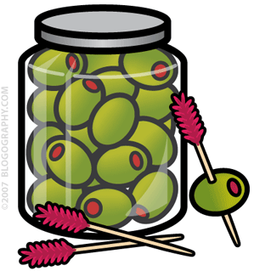 | 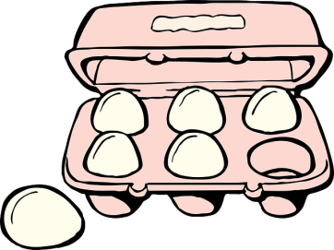 | 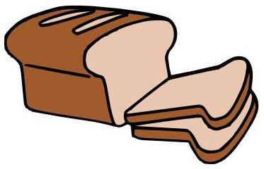

C) LOOK AT THE TABLE AND MAKE A DIALOGUE AS IN THE EXAMPLE GIVEN BELOW (4x5: 20 PTS)
MARTIN
Watch TV
100%
Go online
100%
Go shopping
%75
Get up late
%25
Tidy his room
0%

TEACHER : How often do you watch TV?
MARTIN : I always watch TV.
TEACHER : How often do you go online?
MARTIN : …………………………………………
TEACHER : How often do you go shopping?
MARTIN : …………………………………………
TEACHER : How often do you get up late?
MARTIN : …………………………………………
TEACHER : How often do you tidy his room?
MARTIN : …………………………………………
Baki ÖZEN
İngilizce Öğretmeni
D) LOOK AT THE TABLE AND WRITE THE CORRECT SENTENCES (4x5: 20 PTS)

: like | : love | : don’t like | : hate

Honey | Jam
Banana | Milk
Chocolate | Cola
Cucumber | Tomato
Croissants | Sausages
0- I like honey and jam.

1- ………………………………………………….

2- ………………………………………………….

3- ………………………………………………….

4- ………………………………………………….

E) WRITE THE TURKISH MEANINGS OF THE GIVEN PHRASES BELOW (4x3: 12 PTS)

- Enjoy your meal : ……………………………………………….
- Would you like to drink tea? : ……………………………………………….
- It’s my favourite : ……………………………………………….
- Traditional : ……………………………………………….
Baki ÖZEN
İngilizce Öğretmeni

