- What time is it? (02:25)
- It is half past two
- It is two o’clock.
- It is twenty-five past two.
- It is thirty-five to eleven.

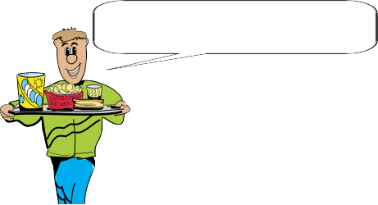
- I - - - - in the afternoons.

  - have a snack
  - hang around
  - have a rest
  - go shopping



- What does Mert do in the evenings?
- He watches TV with his parents.
- He goes out and meets friends.
- He hangs around with his friends.
- He goes online and chats with friends.

- Dave : - - - -?
Joe : After dinner in the evenings.
- What time do you get up
- What is your favorite after school activity
- Do you study your school subjects
- When do you do your homework

- Andy : What do you do after school?
Mike : - - - -.
A) It is at 8.00 am on Sunday afternoon
B) I usually meet my friends and we have fun
C) I always get up early in the mornings
D) My favorite dance is Flamenco

- Andy : Yummy! Breakfast looks great, mum.
Mother : Yes, you are right. What would
you like to drink?
Andy : _ _ _ _ _ _ please.
Mother : Here you are. Enjoy your meal.
Andy : Thank you.
  - A piece of cheese
  - A glass of milk
  - A few olives
  - A boiled egg

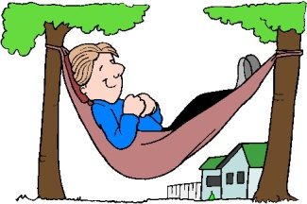
- A: What does he do at
half past four ?
B: He _ _ _ _ _ _

    - Hangs around
    - Listens to music
    - Visit his parents
    - Have a rest

- Choose the correct form of the verbs in the brackets. (7 X 3 = 21)

- Teoman …….. (play / plays) the guitar after school.
- Mike and I …….. (study ( studies) English in the evenings.
- My brother …….. (don’t / doesn’t) visit his relative after school
- I always …….. (run errands / runs errands) at home.
- They …….. (don’t / doesn’t) drink milk at night.
- My father …….. (get / gets) up late on Sundays.
- My sister doesn’t …….. (help / helps) my mother.
- Does your brother usually …….. (go / goes) to dance club after school ?

- Write do or does and match the questions with their answers.

- What time ……. Merve go to school?
- What ……. your brother do after school?
- ……. your father always watch TV?
- When ……. your friends study English
for the exam?
- ……. you like watching cartoon at home?

- Match the times.
11:00 ……….
e. half past seven

- alf past seven
d. quarter past ten

- alf past seven
c. twenty to six
b. eleven o’clock
a. quarter to five

07:30 ……….

16:45 ……….
10:15 ……….

17:40 ……….

- Sezai : What does your brother do after
school?
Sinan : …………..
- I listen to music.
- He plays video games.
- She goes to cinema.
- They often read a book.

- My sister …….. watching cartoon very much.
- like C) is like
- are like D) likes

- Yes, I do. Tom and Jerry is my favorite.
- My friends always study after school.
- No, he doesn’t. He hates it.
- He usually listens to music.
- At half past six in the morning.

- A: Do Ayşe and Pelin …….. playing piano ?
B: No, they don’t. They …….. playing piano.
- Like / dislike
- Hate / dislike
- Does / likes
- Is / don’t like

- Can I have some salami, please?
- No, thanks. I don’t like tea.
- Sorry, no. It is all gone.
- Yes, please. I like honey.
- Yes, you can.

- Do you want some bread and honey?
- Yes, please. I like honey.
- Sorry, no. I don’t like milk.
- Yes, you can.
- No, thanks. I don’t want any tea.
NOT: Testler 5’er puan.
8. soru 21 puan.
9. ve 10. Soru 10’ar puan.

