AD/SOYAD: NUMARA:
2015-2016 EĞİTİM ÖĞRETİM YILI E.T.S.O. ORTAOKULU 6. SINIFLAR 1. DÖNEM 1. YAZILI SINAV SORULARI

A) Etkinlikleri resimlerle eşleştirin. (16 puan)
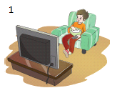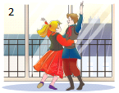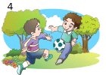
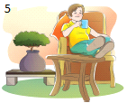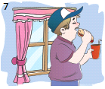
___A) take guitar courses ___B)have a snack ___C)watch TV ___D)have a rest
___E)go online ___F)play soccer ___G)go to dance ___H)do homework
B) Eşleştirin. (21 puan)
___1- What do you do after school? A) At 3:15.
___2- What time do you arrive home? B) Yes, I do.
___3- Do you do your homework in the evening? C) At weekends.
___4- How often do you go shopping with your mother? D) I play soccer with friends.
___5- When do you visit your grandparents? E) Never.
___6- Does Pierre prefer milk to coffee? F) Jane.
___7- Who does’nt like olives? G) Yes, he does.
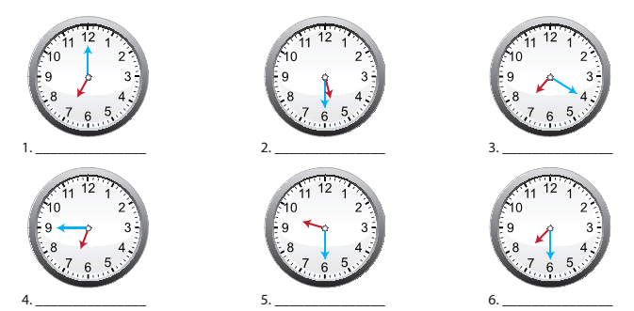C) Saatlerle cümleleri eşleştirin.(12 puan)
a) It is seven o’clock.
b) It is twenty past seven.
c) It is half past seven
d) It is quarter to seven
e) It is half past five.
f) It is haf past nine

D) Yiyecek ve içeceklerin isimlerini yazınız. (20 puan)
Olives | Croissants | Tomatoes | Eggs | Salami | Butter | Milk | Honey | Sausages | cheese
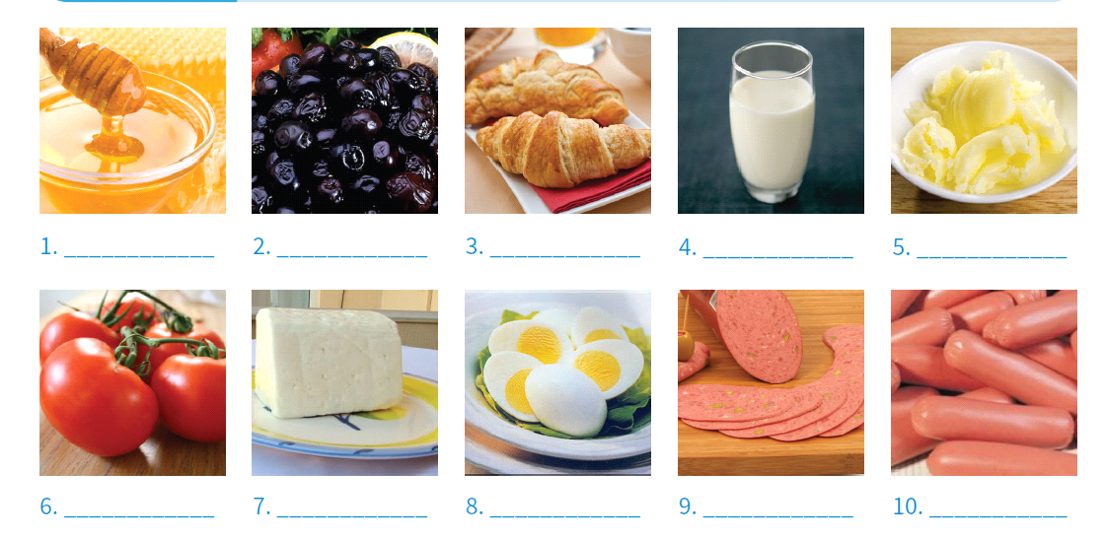
E) Resme göre cümleler doğruysa ‘T’ yanlışsa ‘F’ yazın. (10 puan)
1) 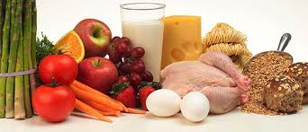…………. There is some bread.
2) …………..There isn’t any chicken.
3) …………..There are some carrots.
4) …………… There are two cucumbers.
5) ……………There are some grapes.
F) Match the labels and the products. (8 puan)
1- 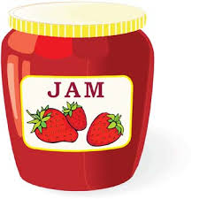2- 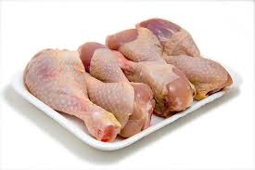3- 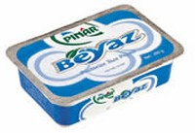4- 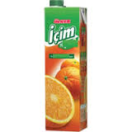
___a) Shake well before opening! ___c) Keep in freezer!
___b) Store in room temperature! ___d) Made from natural cow milk!
a) Yes, please. d) No, thanks.
b) Would you like e) It’s all gone.
c) I’m full. f) It’s my favourite.

G) Aşağıdaki ifadeleri kullanarak diyaloğu tamamlayın. (12 puan)
Jane: Would you like some cheese, Katio?
Katio: (1)………………………… . I love cheese.
Jane: Want some fruit salad, Sophie?
Sophie: (2)…………………………… . I don’t eat fruit for breakfast.
Katio: Can I have some more cheese, please?
Jane: I’m sorry, (3)……………………………………….. . Would you like some cereal instead?
Katio: Yes. Yummy. (4)……………………………………………… .
Jane: (5)…………………………………. something else, Sophie?
Sophie: Oh, no. (6) ……………………………………………. . Teacher: Neslihan KURBAN

